Game Programming Project Report

Tolu Bankole: 0876923: tobankol@lakeheadu.ca

Game Concept: You are a contestant on an obstacle course and your goal is to make it through without getting killed and you have to collect all the pineapples.

The **Design** of the game is a simple Platformer style game with 3 different levels to play through with increasing difficulty.

I tried to make the game dynamically, and this includes the use of prefabrications for easy level building. It also helps keep the theme of the game.

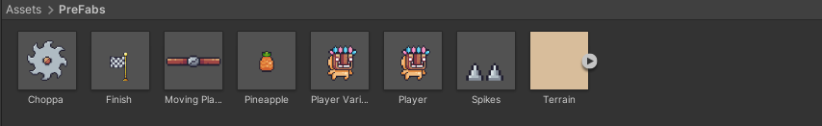

I used a Tile Map style world to lay the graphics in the game.

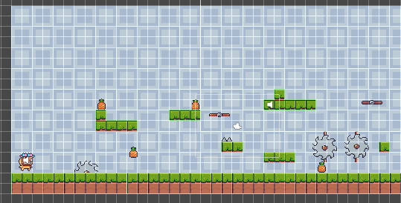

The animations and graphics are all from sprites sourced from the internet.

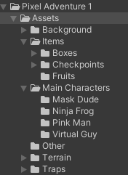

I created the transitions using the tutorials shown in class.

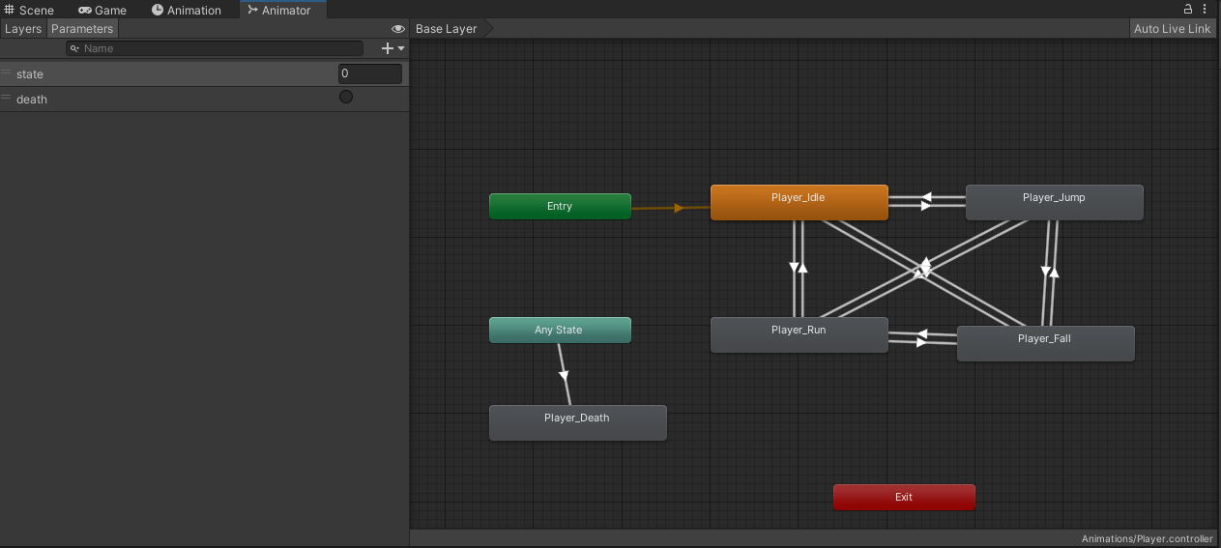

The sounds are from an assets pack in the Unity Asset Store.

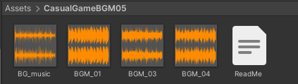

I created different Scenes so that there can be different levels to the game.

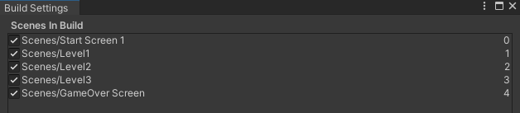

The C# Scripts pictures are included below.

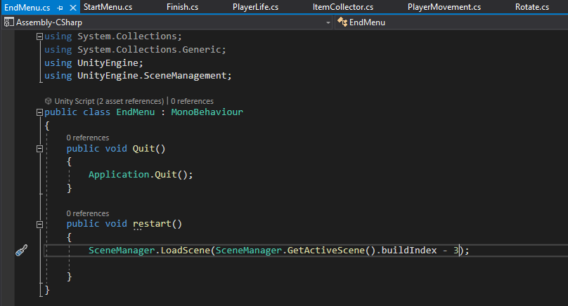

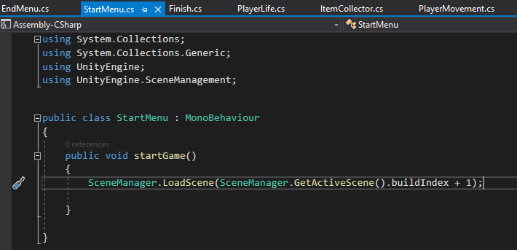

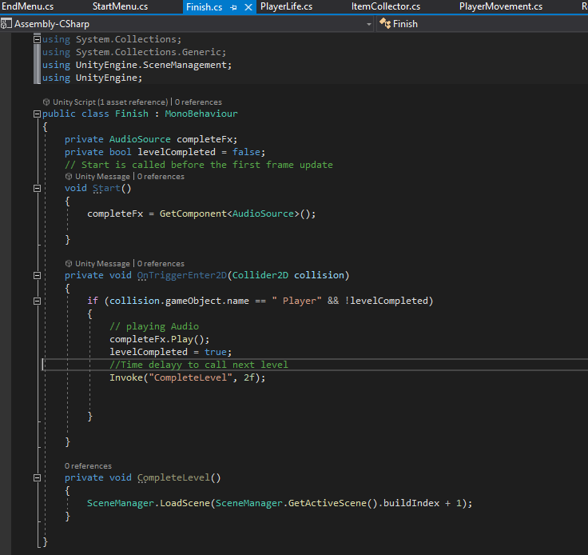

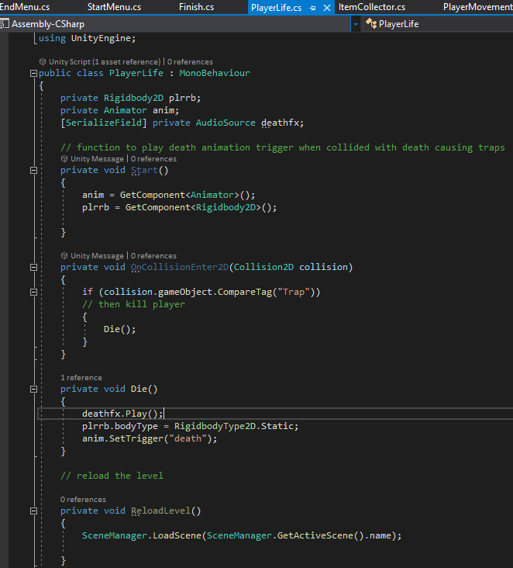

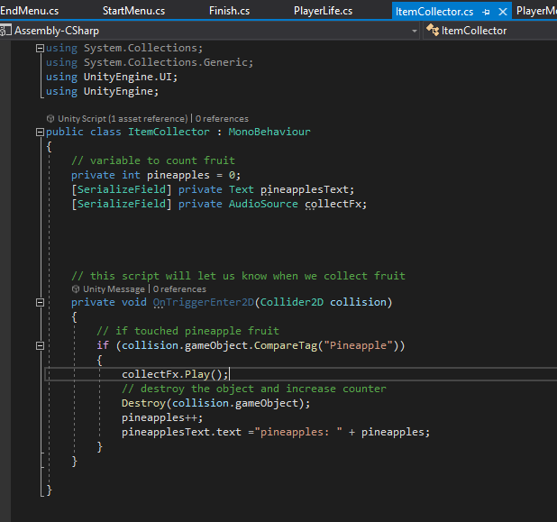

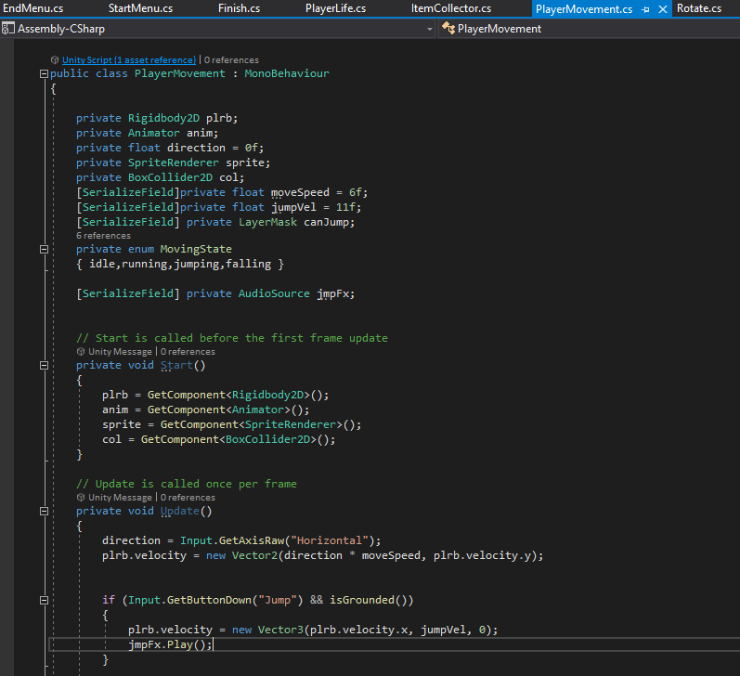

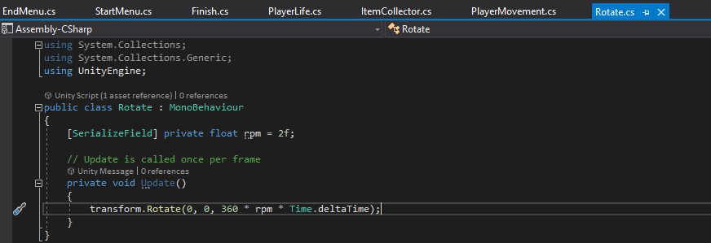

Included below are the links to my resources.

[Pixel Adventure 1 | 2D Characters | Unity Asset Store](https://assetstore.unity.com/packages/2d/characters/pixel-adventure-1-155360)

[FREE Casual Game SFX Pack | Audio Sound FX | Unity Asset Store](https://assetstore.unity.com/packages/audio/sound-fx/free-casual-game-sfx-pack-54116)

[Casual Game BGM #5 | Audio Music | Unity Asset Store](https://assetstore.unity.com/packages/audio/music/casual-game-bgm-5-135943)